Mikael Simon

5/3/16

Project 2

**Part 1)**

###ACF and PACF of x



####acf and pacf of the residuals of the best model of ARIMA(p.best,d.best,q.best)



**Part 2)**

###Acf and pacf of residuals of the least squares model



> stargazer(best.model,best.model2,best.model3,type="text")

===============================================

Dependent variable:

-----------------------------

x

(1) (2) (3)

-----------------------------------------------

ar1 1.375*** 0.988*** 1.746***

(0.247) (0.126) (0.231)

ar2 -0.896* -0.578*** -1.399***

(0.519) (0.180) (0.495)

ar3 -0.185 0.070 0.726

(0.589) (0.194) (0.502)

ar4 0.305 -0.178 -0.413*

(0.403) (0.189) (0.237)

ar5 -0.348 -0.113

(0.281) (0.192)

ar6 0.313 0.197

(0.230) (0.176)

ar7 -0.446*** -0.447***

(0.138) (0.121)

ma1 -1.543*** -1.000*** -2.028***

(0.258) (0.056) (0.237)

ma2 0.657 1.146**

(0.567) (0.523)

ma3 0.594 -0.164

(0.561) (0.519)

ma4 -0.708*** 0.097

(0.259) (0.334)

ma5 0.222

(0.329)

ma6 0.002

(0.339)

ma7 -0.903***

(0.333)

ma8 0.631***

(0.173)

intercept 0.008*** 0.007*** 0.008***

(0.002) (0.002) (0.001)

-----------------------------------------------

Observations 60 60 60

Log Likelihood 9.777 6.472 9.779

sigma2 0.033 0.041 0.031

Akaike Inf. Crit. 6.446 7.056 8.443

===============================================

Note: *p<0.1; **p<0.05; ***p<0.01

All of the three best models with the lowest AIC were ARMA models, d=0.

**Part 3)**

For this project I used the Canada dataset from the VARS package in R. The dataset was made up of four time series variables of the dependent variable C.e (employment), and independent variables of C.prod (labour productivity), and C.rw (real wage), C.U (unemployment rate). I also created four more independent variables for the differences of the first four variables. I then plotted the acf and pacf of each variable to see if there was significant autocorrelation with any variable, these plots are shown in FIG.1.

I then plotted the ccf of C.e against all the indepent variables to decide which variables would be used to fit my least squares model, which is shown in Fig.2. From these ccf plots I saw that C.prod, C.rw, and C.U all had significant cross correlation at lag(0). There was also significant cross correlation for C.U at lag(-4), lag(1), and lag(2), diff.C.rw at lag(-2), and lag(-1, and diff.C.U at lag (-1). From this I was able to fit a least squares regression model of:

(C.e~C.prod+C.rw+C.U+C.U.lag.1+C.U.lag.2+C.U.lag.3+diff.C.rw.lag.1+diff.C.rw.lag.2+diff.C.U.la)

I then plotted the acf and pacf of the residuals of the fitted least squares model, to check for autocorrelation, which is shown in Fig.3. From these acf and pacf plots I saw that there was significant autocorrelation for the fitted least squares regression model.

Next I wanted to fit an ARMA(p,q) process to the residuals of the least squares model to deal with the autocorrelation seen in the least squares model. I found the model with the lowest AIC, which ended up being and ARMA(2,4).

Finally I fitted a general least squares model based off the parameters of the ARMA(2,4) process. From the results of the general least squares model, Fig.4, I saw that C.prod, C.rw, Cu.U, diff.C.rw.lag.1, and diff.C.U.lag1 all had significant coefficients in the regression model.

From this I would say that labour productivity, real wage, unemployment rate, difference of real wage at a lag of -2, and the difference of unemployment at a lag of -1, all are useful and significant for the dependent variable of employment. This makes sense since from economic theory we know that labour productivity, real wage, and unemployment all have an effect on employment. Economic theory also tells us the real wages are sticky, and would have a slow lagging effect on employment, which explains why the difference of real wage at a lag -2 has an effect on employment. Economic theory also explains that unemployment is a lagging indicator which explains why difference of unemployment at a lag of -1 is included in the model.

**Figures and Graphs**

**## FIG.1 ACF and PACF plots of all the variables**

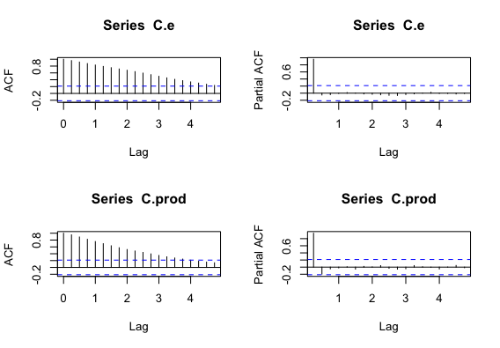

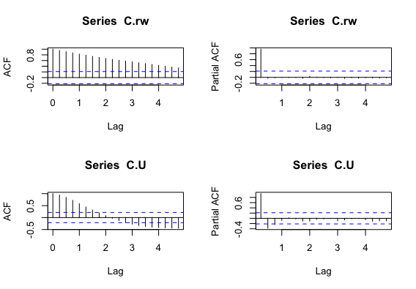

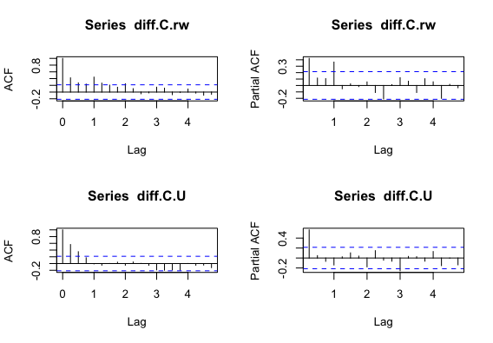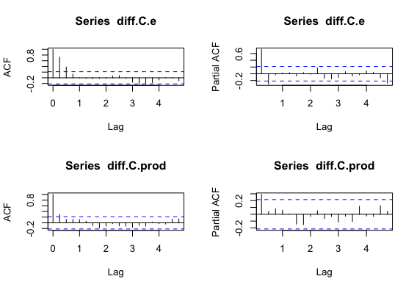

**## FIG.2 CCF Plots of all the covariates with C.e**

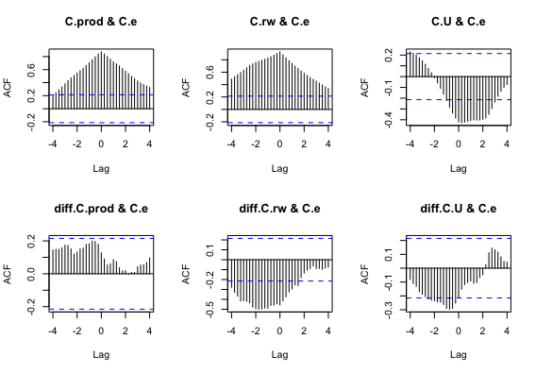

**### FIG.3 ACF and PACF plot of the fitted**

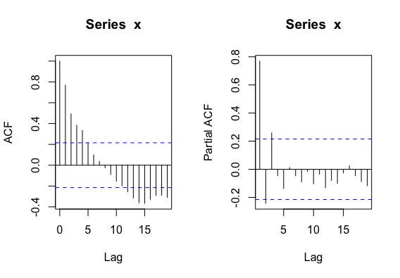

**###Fig.4**

**GLS Regresion Results**

===============================================

Dependent variable:

---------------------------

C.e

-----------------------------------------------

C.prod 0.207***

(0.057)

C.rw 0.322***

(0.009)

C.U -1.673***

(0.120)

diff.C.rw.lag.1 0.127***

(0.041)

diff.C.U.lag1 -0.470***

(0.138)

Constant 733.112***

(21.590)

-----------------------------------------------

Observations 83

Log Likelihood -51.002

Akaike Inf. Crit. 136.004

Bayesian Inf. Crit. 174.941

===============================================

Note: *p<0.1; **p<0.05; ***p<0.01

APPENDIX:

**PART 1:**

x <- arima.sim(list(ar=c(0.7,-0.5,.3),

ma=c(0.7,0.5,0.2)),n = 500)

####plot the acf and pacf of x

acf(x)

pacf(x)

max.order <- 10

AIC.matrix <- list()

###Fit a series of ARIMA models with 0 ≤ p ≤ 10, 0 ≤ q ≤ 10, 1 ≤ d ≤ 3,

##and store the AIC of each fit.

max.d <- 3

for(d in 0:max.d){

AIC.temp.matrix <- matrix(0,nrow = max.order+1,ncol= max.order+1)

for(i in 1:(max.order+1)){

for(j in 1:(max.order+1)){

currentArima <- arima(x,order=c(i-1,d,j-1))

AIC.temp.matrix[i,j] <- AIC(currentArima)

}

}

AIC.matrix[[d+1]] <- AIC.temp.matrix

}

###find the minimum aic of each AIC matrix, and store minimum aic of each matrix

d.0<-min(AIC.matrix[[1]]) ##ARIMA(0 ≤ p ≤ 10,0,0 ≤ q ≤ 10)

d.1<-min(AIC.matrix[[2]]) ##ARIMA(0 ≤ p ≤ 10,1,0 ≤ q ≤ 10)

d.2<-min(AIC.matrix[[3]]) ##ARIMA(0 ≤ p ≤ 10,2,0 ≤ q ≤ 10)

d.3<-min(AIC.matrix[[4]]) ##ARIMA(0 ≤ p ≤ 10,3,0 ≤ q ≤ 10)

###create list of AIC of the minimum of the AIC matrices, and find the

###minimum AIC of ARIMA models of 0≤ d ≤3

d.list<-list(d.0,d.1,d.2,d.3)

d.best<-which.min(d.list)

###find the row and column of the lowest AIC.

arrayInd(which.min(AIC.matrix[[d.best]]), dim(AIC.matrix[[d.best]]))

aic.col=arrayInd(which.min(AIC.matrix[[d.best]]), dim(AIC.matrix[[d.best]]))[2]

aic.row=arrayInd(which.min(AIC.matrix[[d.best]]), dim(AIC.matrix[[d.best]]))[1]

## store p,d,q of the best model

p.bestmodel=aic.row-1

d.bestmodel=d.best-1

q.bestmodel=aic.col-1

####fit the best model

best.model<-arima(x,order=c(p.bestmodel,d.bestmodel,q.bestmodel))

##plot the residuals of the best models acf and pacf.

acf(best.model$residuals)

pacf(best.model$residuals)

**PART 2:**

##install packages

install.packages("devtools")

install.packages("dplyr")

install.packages("pbapply")

install.packages("stringr")

devtools::install_github("hrbrmstr/omdbapi")

library(dplyr)

library(pbapply)

library(omdbapi)

getTv <- function(OUR_TITLE,OUR_YEAR=NA){

x <- c()

x.season <- c()

x.episode <- c()

#loop over seasons (Assuming maximum of 50 seasons)

for(this.season in 1:50){

#check if this season exists, otherwise break the for loop

if(dim(find_by_title(OUR_TITLE,type="episode",

season=this.season,

episode=1,

year_of_release = OUR_YEAR))[1] == 0){

break

} else {

#now go over the episodes

#first wait for 2 seconds (this amount probably needs to be higher)

#(we don't want to get blacklisted from the API)

print("Waiting for 2 seconds...")

Sys.sleep(2)

#looping over episodes (maximum is 50)

for(this.episode in 1:50){

if(dim(find_by_title(OUR_TITLE,

type="episode",

season=this.season,

episode=this.episode,

year_of_release = OUR_YEAR))[1] == 0){

break

} else {

if(this.episode %% 9 ==0){

print("Waiting for 2 seconds...")

Sys.sleep(2)

}

this.rating <- find_by_title(OUR_TITLE,

type="episode",

season=this.season,

episode=this.episode,

year_of_release = OUR_YEAR)$imdbRating

x <- c(x,this.rating)

x.season <- c(x.season,this.season)

x.episode <- c(x.episode,this.episode)

}

}

}

}

return(data.frame(x=x,season=x.season,episode=x.episode))

}

##choose what tv show and name it OUR_TITLE

OUR_TITLE <-"The Wire"

##check if the show is on imdb

res.1<-search_by_title(OUR_TITLE,type="series")

res.1

#Check if it has ratings

find_by_title(OUR_TITLE, type="episode", season=1, episode=1)$imdbRating

Wire<-getTv(OUR_TITLE,OUR_YEAR = 2002)

x<-Wire$x

###FIT a least squares model

lm1 <- lm(x~factor(season)-1,data=Wire)

##report the summary of the least squares model

summary(lm1)

## plot the residuals of the fitted model

x <- lm1$residuals

ts.plot(x)

acf(x)

pacf(x)

max.order <- 10

AIC.matrix <- list()

###Fit a series of ARIMA models with 0 ≤ p ≤ 10, 0 ≤ q ≤ 10, 1 ≤ d ≤ 3,

##and store the AIC of each fit.

max.d <- 3

for(d in 0:max.d){

AIC.temp.matrix <- matrix(0,nrow = max.order+1,ncol= max.order+1)

for(i in 1:(max.order+1)){

for(j in 1:(max.order+1)){

AIC.temp.matrix[i,j] <- tryCatch(

{

#try

currentArima <- arima(x,order=c(i-1,d,j-1))

AIC(currentArima)

},

error=function(cond){

errMessage <- paste(i-1,d,j-1,sep=",")

errMessage <- paste0("Error in fitting ARIMA(",errMessage,"), setting AIC to 10^6")

message(errMessage)

return(10^6)

},

warning=function(cond){

errMessage <- paste(i-1,d,j-1,sep=",")

errMessage <- paste0("Error in fitting ARIMA(",errMessage,"), setting AIC to 10^6")

message(errMessage)

return(10^6)

})

}

}

AIC.matrix[[d+1]] <- AIC.temp.matrix

}

###find the minimum aic of each AIC matrix, and store minimum aic of each matrix

d.0<-min(AIC.matrix[[1]]) ##ARIMA(0 ≤ p ≤ 10,0,0 ≤ q ≤ 10)

d.1<-min(AIC.matrix[[2]]) ##ARIMA(0 ≤ p ≤ 10,1,0 ≤ q ≤ 10)

d.2<-min(AIC.matrix[[3]]) ##ARIMA(0 ≤ p ≤ 10,2,0 ≤ q ≤ 10)

d.3<-min(AIC.matrix[[4]]) ##ARIMA(0 ≤ p ≤ 10,3,0 ≤ q ≤ 10)

###create list of AIC of the minimum of the AIC matrices, and find the

###minimum AIC of ARIMA models of 0≤ d ≤3

d.list<-list(d.0,d.1,d.2,d.3)

d.best<-which.min(d.list)

###find the 2nd and 3rd lowest AIC from the aic.matrix(d.best) with the lowest aic.

n <- length(AIC.matrix[[d.best]])

min.aic2<-sort(AIC.matrix[[d.best]],partial=n-119)[n-119]

min.aic3<-sort(AIC.matrix[[d.best]],partial=n-118)[n-118]

###find the row and column of the lowest AIC.

arrayInd(which.min(AIC.matrix[[d.best]]), dim(AIC.matrix[[d.best]]))

aic.col=arrayInd(which.min(AIC.matrix[[d.best]]), dim(AIC.matrix[[d.best]]))[2]

aic.row=arrayInd(which.min(AIC.matrix[[d.best]]), dim(AIC.matrix[[d.best]]))[1]

## store p,d,q of the best model

p.bestmodel=aic.row-1

d.bestmodel=d.best-1

q.bestmodel=aic.col-1

####fit the 3 best models of lowest aic

best.model<-arima(x,order=c(p.bestmodel,d.bestmodel,q.bestmodel))

best.model2<-arima(x,order=c(7,0,1))

best.model3<-arima(x,order=c(4,0,8))

##plot the residuals of the best model acf and pacf.

acf(best.model$residuals)

pacf(best.model$residuals)

##install stargazer which helps me create a table of the arima results to compare the 3 best models.

install.packages("stargazer")

library(stargazer)

regression_results<-stargazer(lm1,gls1, type="text",title = "Regression Results")

stargazer(best.model,best.model2,best.model3,type="text")

**PART 3:**

##install stargazer which helps me create a table of the arima results to compare the 3 best models.

install.packages("stargazer")

library(stargazer)

##install nlme to run gls regression

install.packages("nlme")

library(nlme)

###install vars package and load canada data set

install.packages("vars")

library(vars)

data(Canada)

##Save the columns of Canada as separate ts() variables, and change the names of the variables

C.e<-ts(Canada[,1],start=c(1980,1), end=c(2000,4), frequency=4 )# dependent variable,(employment)

C.prod<-ts(Canada[,2],start=c(1980,1), end=c(2000,4), frequency=4) #independent variable, (labour productivity)

C.rw<-ts(Canada[,3],start=c(1980,1), end=c(2000,4), frequency=4 ) #independent variable, (real wage)

C.U<-ts(Canada[,4],start=c(1980,1), end=c(2000,4), frequency=4 ) #independent variable, (unemplotment rate)

##difference the variables and store as new variables

diff.C.e<-diff(C.e)

diff.C.prod<-diff(C.prod)

diff.C.rw<-diff(C.rw)

diff.C.U<-diff(C.U)

###acf and pacf of all time series variables, including the differenced series

acf(C.e)

pacf(C.e)

acf(C.prod)

pacf(C.prod)

acf(C.rw)

pacf(C.rw)

acf(C.U)

pacf(C.U)

acf(diff.C.e)

pacf(diff.C.e)

acf(diff.C.prod)

pacf(diff.C.prod)

acf(diff.C.rw)

pacf(diff.C.rw)

acf(diff.C.U)

pacf(diff.C.U)

###Plot the ccf between C.e and all other covariates.

ccf(C.prod,C.e)##plot shows significant cross correlation in lag(0)

ccf(C.rw,C.e)##plot shows significant cross correlation in lag(0)

ccf(C.U,C.e)##plot shows significant cross correlation at lag(0),lag(-4),lag(1),lag(2)

ccf(diff.C.prod,C.e)##plot shows no significant cross correlation

ccf(diff.C.rw,C.e)###plot shows significant cross correlation at lag(-2),lag(-1)

ccf(diff.C.U,C.e)###shows significant cross correlation at lag(-1)

###create lag versions of variables that have signifcant cross correlation.

C.U.lag.1<-lag(C.U[-84],-4)

C.U.lag.2<-lag(C.U[-84],1)

C.U.lag.3<-lag(C.U[-84],2)

diff.C.rw.lag.1<-lag(diff.C.rw,-2)

diff.C.rw.lag.2<-lag(diff.C.rw,-1)

diff.C.U.lag1<-lag(diff.C.U,-1)

###fit a least squares regression model with the covariates that have a significant cross correlation with C.e

###make sure all the variable are thame same length

C.e<-C.e[-84]

C.U<-C.U[-84]

C.prod<-C.prod[-84]

C.rw<-C.rw[-84]

lm.1<-lm(C.e~C.prod+C.rw+C.U+C.U.lag.1+C.U.lag.2+C.U.lag.3+diff.C.rw.lag.1

+ diff.C.rw.lag.2+diff.C.U.lag1)

##Plot the acf and the pacf of the residuals of the fitted least squares model

x<-lm.1$residuals

acf(x)

pacf(x)

###Fit a series of ARIMA models with 0 ≤ p ≤ 10, 0 ≤ q ≤ 10, 1 ≤ d ≤ 3,

##and store the AIC of each fit.

max.order <- 10

AIC.matrix <- list()

max.d <- 3

for(d in 0:max.d){

AIC.temp.matrix <- matrix(0,nrow = max.order+1,ncol= max.order+1)

for(i in 1:(max.order+1)){

for(j in 1:(max.order+1)){

AIC.temp.matrix[i,j] <- tryCatch(

{

#try

currentArima <- arima(x,order=c(i-1,d,j-1))

AIC(currentArima)

},

error=function(cond){

errMessage <- paste(i-1,d,j-1,sep=",")

errMessage <- paste0("Error in fitting ARIMA(",errMessage,"), setting AIC to 10^6")

message(errMessage)

return(10^6)

},

warning=function(cond){

errMessage <- paste(i-1,d,j-1,sep=",")

errMessage <- paste0("Error in fitting ARIMA(",errMessage,"), setting AIC to 10^6")

message(errMessage)

return(10^6)

})

}

}

AIC.matrix[[d+1]] <- AIC.temp.matrix

}

###find the minimum aic of each AIC matrix, and store minimum aic of each matrix

d.0<-min(AIC.matrix[[1]]) ##ARIMA(0 ≤ p ≤ 10,0,0 ≤ q ≤ 10)

d.1<-min(AIC.matrix[[2]]) ##ARIMA(0 ≤ p ≤ 10,1,0 ≤ q ≤ 10)

d.2<-min(AIC.matrix[[3]]) ##ARIMA(0 ≤ p ≤ 10,2,0 ≤ q ≤ 10)

d.3<-min(AIC.matrix[[4]]) ##ARIMA(0 ≤ p ≤ 10,3,0 ≤ q ≤ 10)

###create list of AIC of the minimum of the AIC matrices, and find the

###minimum AIC of ARIMA models of 0≤ d ≤3

d.list<-list(d.0,d.1,d.2,d.3)

d.best<-which.min(d.list)

###find the row and column of the lowest AIC.

arrayInd(which.min(AIC.matrix[[d.best]]), dim(AIC.matrix[[d.best]]))

aic.col=arrayInd(which.min(AIC.matrix[[d.best]]), dim(AIC.matrix[[d.best]]))[2]

aic.row=arrayInd(which.min(AIC.matrix[[d.best]]), dim(AIC.matrix[[d.best]]))[1]

## store p,d,q of the best model

p.bestmodel=aic.row-1

d.bestmodel=d.best-1

q.bestmodel=aic.col-1

###fit a arima model, with the parameters of the best model with the lowest aic

best.model <- arima(C.e,order=c(p.bestmodel,d.bestmodel,q.bestmodel))

##fit a generalized least squares model using the order of the best model we just fitted

gls1 <- gls(C.e~C.prod + C.rw + C.U + C.U.lag.1 + C.U.lag.2 + C.U.lag.3

+ diff.C.rw.lag.1

+ diff.C.rw.lag.2 + diff.C.U.lag1,

data=Canada,

correlation = corARMA(value = .5*coef(best.model)[1:6],p=2,q=4),

control = list(singular.ok = TRUE) )

##look at the summary of the generalized least square and least squares model and comparethem.

summary(gls1)

####create table of results of gls model

regression_results<-stargazer(gls1, type="text",title = "Regression Results")